page2image568

SQL Training

Lesson-End Project Solution



**School Ranking Analysis**

1. Write a query to create a **students** table with the student ID, first name, last name, class, and age fields and ensure that the last name, first name, and student ID fields have the NOT NULL constraint and that the student ID field is a primary key

**SQL code:**

CREATE TABLE lep_5.students (

s_id INT NOT NULL,

s_fname varchar(45) NOT NULL,

s_lname varchar(45) NOT NULL,

class varchar(45) NULL,

age INT NOT NULL,

PRIMARY KEY(s_id));

1. Write a query to create a **marksheet** table with score, year, ranking, class, and student ID fields

**SQL code:**

CREATE TABLE lep_5.marksheet (

score INT NOT NULL,

year INT NULL,

class varchar(45) NULL,

ranking varchar(45) NULL,

s_id INT NOT NULL);

1. Write a query to insert values into the students and marksheet tables

**SQL code: Students table**

INSERT INTO lep_5. students (s_id,s_fname,s_lname,class,age) VALUES ('01','krishna','gee','10','18');

**SQL code: Marksheet table**

INSERT INTO lep_5. marksheet (score,year,class,ranking,s_id) VALUES ('989','2014','10','1','1');

1. Write a query to display the student ID and first name of every student in the **students** table whose age is greater than or equal to 16 and whose last name is Kumar

**SQL code:**

SELECT s_id,s_fname FROM lep_5.students WHERE s_lname = 'kumar' AND age>=16;

**Output:**

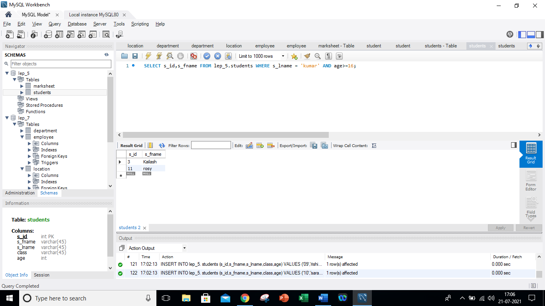

1. Write a query to display the details of every student from the **marksheet** table whose score is between 800 and 1000

**SQL code:**

SELECT * FROM lep_5.marksheet WHERE score BETWEEN 800 AND 1000 ;

**Output:**

1. Write a query to increase the score in the **marksheet** table by five and create a new score column to display this new score

**SQL code:**

SELECT * ,score+5 as new_score FROM lep_5.marksheet ;

**Output:**

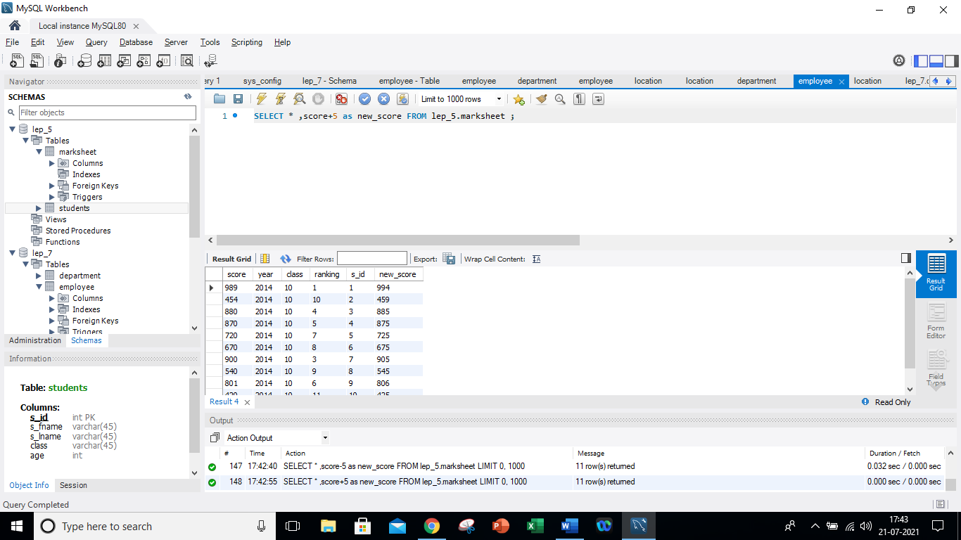

1. Write a query to display the **marksheet** table in descending order of the score

**SQL code:**

SELECT * FROM lep_5.marksheet ORDER BY score DESC ;

**Output:**

1. Write a query to display the **marksheet** table in descending order of the score

**SQL code:**

SELECT * FROM lep_5.students WHERE s_fname LIKE 's%';

**Output:**

